Create MariaDB Database on EC2

Objective
Install MariaDB server on EC2.
Dependency
None.
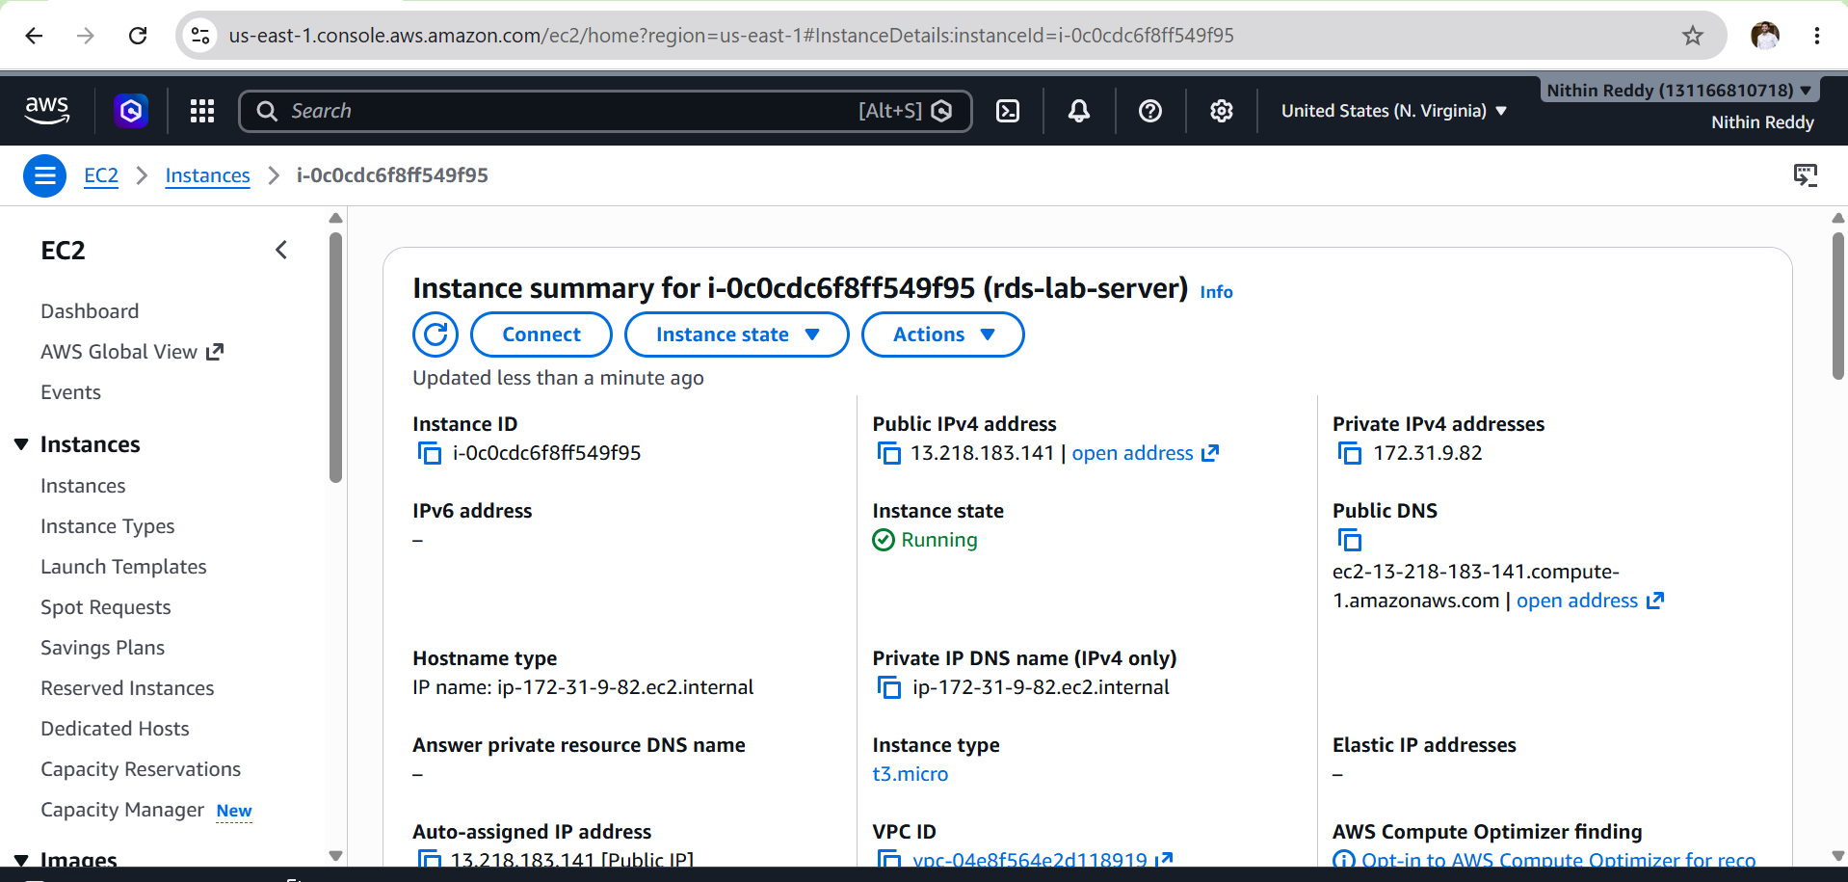
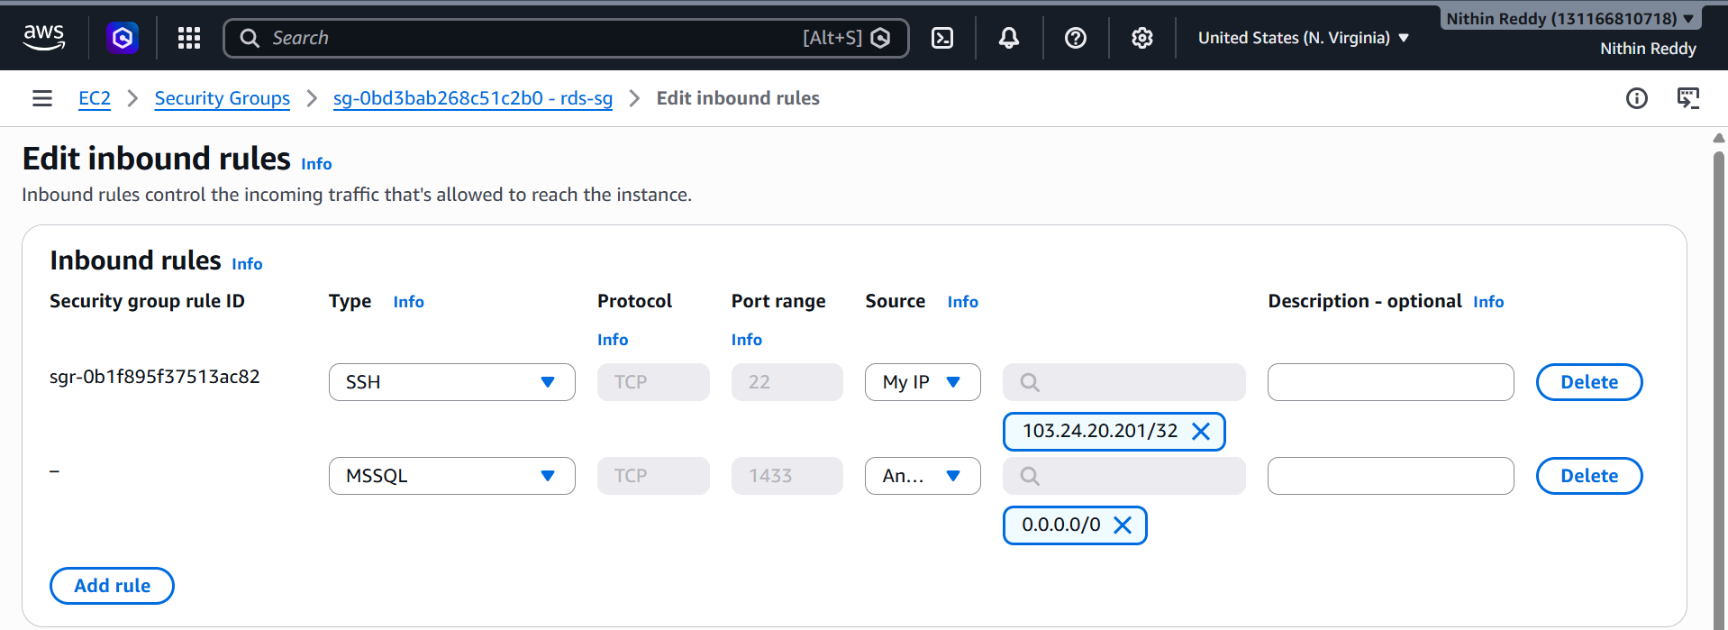
Install MariaDB
Update packages:
sudo dnf update -y
Install MariaDB:
sudo dnf install mariadb105-server -y
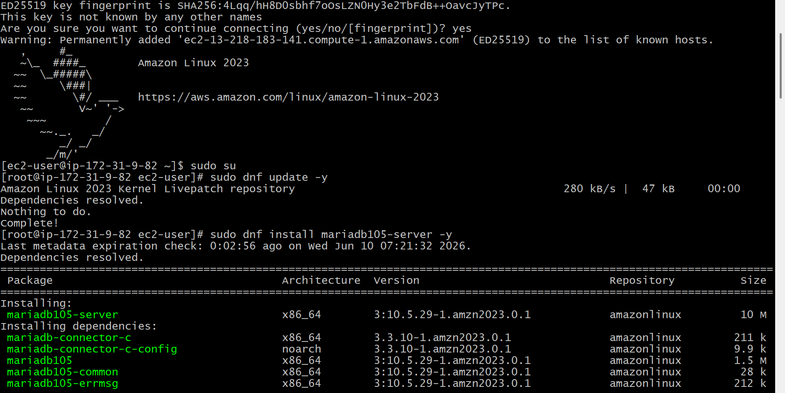
Start Service
sudo systemctl start mariadb
sudo systemctl enable mariadb
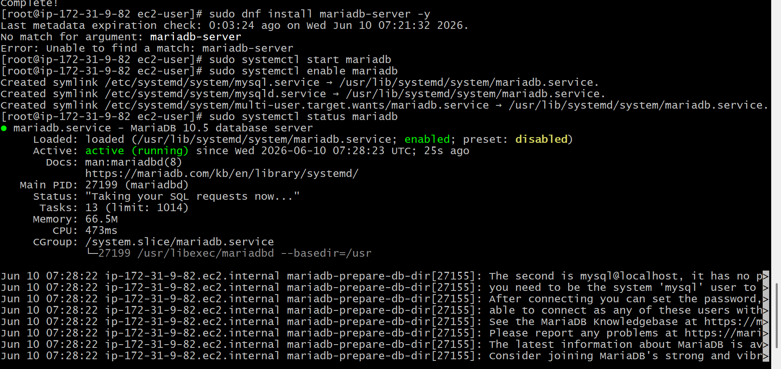
Validation
Check status:
sudo systemctl status mariadb
Expected:
active (running)
Check version:
mysql --version
Expected:
MariaDB
Screenshot Evidence
Take screenshots of:
sudo systemctl status mariadb
and
mysql --version

Common Errors
Package Not Found
Run:
sudo dnf update -y
Then install again.

Insert Dummy Data
Objective
Create database and table.
Outcome
Sample records inserted.
Steps
Step 1: Verify database exists
SHOW DATABASES;
You should see:
companydb

Step 2: Use the database
USE companydb;
Expected:
Database changed
Prompt changes to:
MariaDB [companydb]>

Step 3: Create table
CREATE TABLE employees (
id INT PRIMARY KEY AUTO_INCREMENT,
name VARCHAR(100),
department VARCHAR(50)
);
Expected:
Query OK
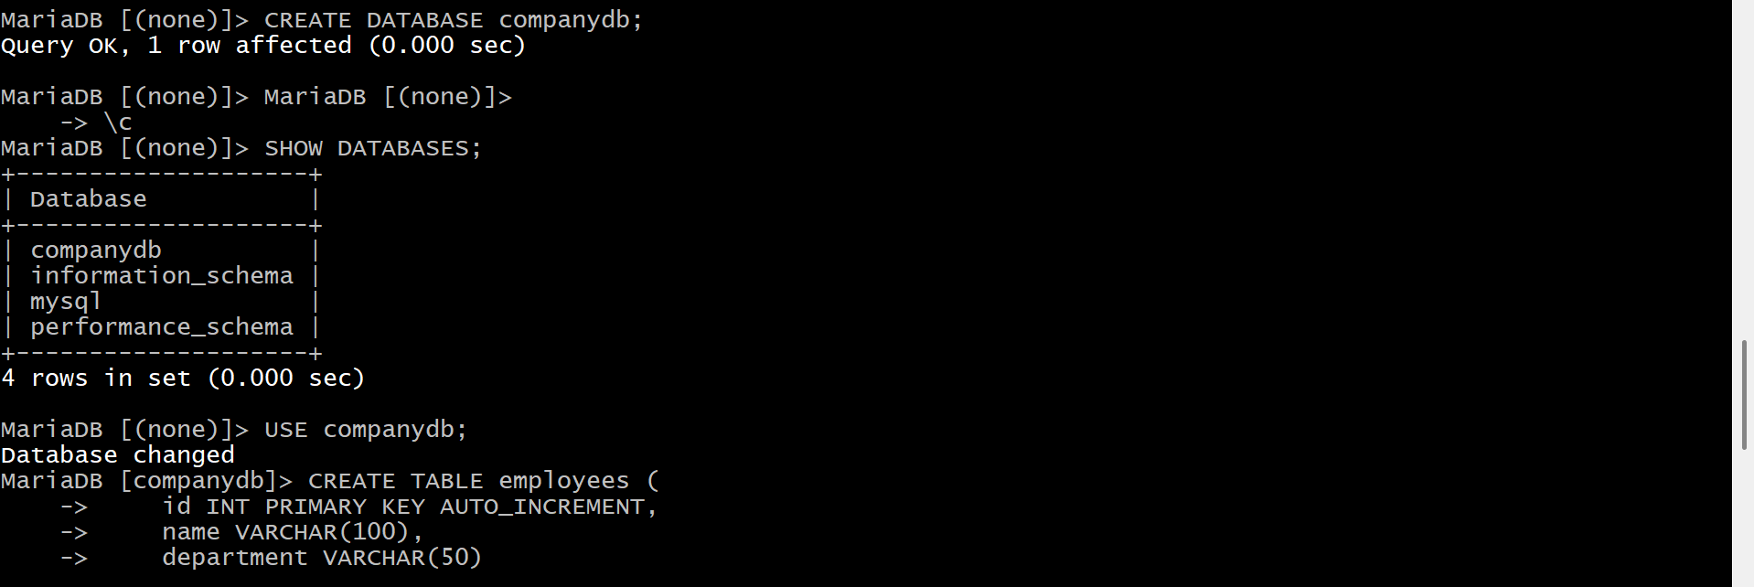
Step 4: Insert dummy records
INSERT INTO employees(name, department)
VALUES
('Nithin', 'DevOps'),
('John', 'AWS'),
('David', 'Cloud');
Expected:
Query OK, 3 rows affected
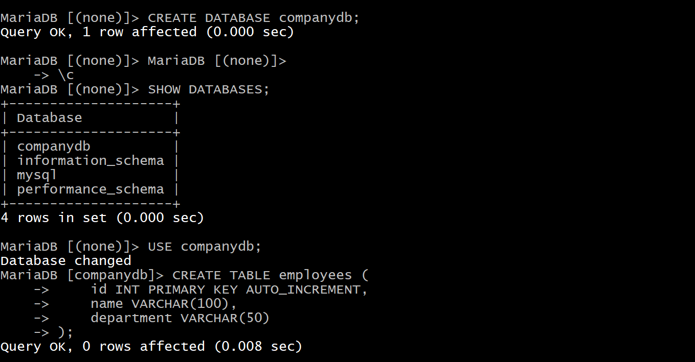
Step 5: Verify data
SELECT * FROM employees;
Expected output:
+----+--------+------------+
| id | name | department |
+----+--------+------------+
| 1 | Nithin | DevOps |
| 2 | John | AWS |
| 3 | David | Cloud |
+----+--------+------------+
📸 Take a screenshot of this output — this is your Task 2 validation evidence.

Step 6: Check table exists
SHOW TABLES;
Expected:
employees
📸 Another good screenshot for evidence.
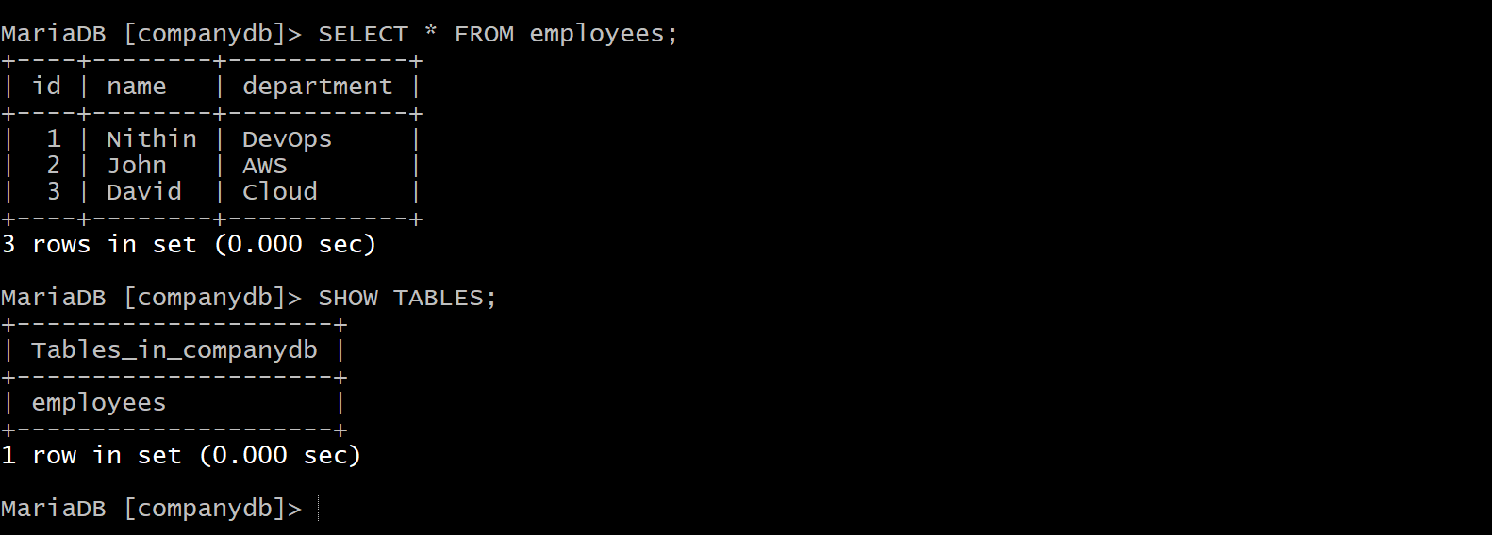
Step 7: Exit MariaDB
exit;
or
quit;
Validation
Output:
3 rows returned
Errors
Access denied
sudo mysql

Backup Dummy Data on EC2
Objective
Take database backup.
Outcome
Backup file generated.
Steps
Step 1: Verify you're back at Linux shell
You should see something like:
[root@ip-172-31-9-82 ec2-user]#
If still inside MariaDB:
exit;

Step 2: Create Backup
Run:
mysqldump -u root companydb > companydb_backup.sql
No output means success.

Step 3: Verify Backup File Exists
ls -lh
Expected output similar to:
-rw-r--r-- 1 root root 2.1K Jun 10 companydb_backup.sql
📸 Take Screenshot #1

Step 4: Check Backup Contents
Show first few lines:
head companydb_backup.sql
Expected output contains something like:
-- MariaDB dump
CREATE TABLE employees
📸 Take Screenshot #2
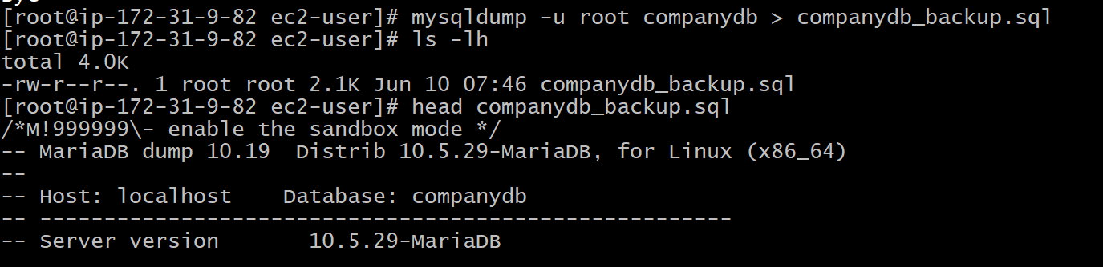
Step 5: Check INSERT Statements
Run:
grep INSERT companydb_backup.sql
Expected:
INSERT INTO `employees`
This proves data was backed up.
📸 Take Screenshot #3

Step 6: Count Lines (Optional Validation)
wc -l companydb_backup.sql
Shows backup file has content.
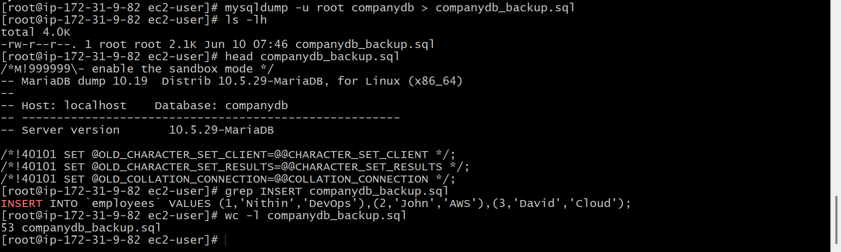
Validation for Task 3
Run:
ls -lh companydb_backup.sql
and
grep INSERT companydb_backup.sql
If both work, Task 3 is complete.

Validation
head companydb_backup.sql
Should show:
CREATE TABLE
INSERT INTO
Errors
mysqldump command not found
sudo dnf install mariadb105 -y

Task 4: Launch MariaDB RDS Instance
Objective
Create a managed MariaDB database in AWS RDS.
Outcome
A MariaDB RDS instance is running and available for connections.
Depends On
❌ Not dependent on previous tasks
But:
✅ Task 5 will use this RDS instance.

Before Creating RDS
Verify Region
Top-right corner of AWS Console:
N. Virginia (us-east-1)
Use the same region as your EC2 instance.

Step 1: Open RDS Console
AWS Console →
RDS
Click:
Create Database

Step 2: Database Creation Method
Choose:
Standard Create
NOT Easy Create.
📸 Screenshot

Step 3: Engine Options
Select:
MariaDB
Version:
Keep default/latest available.
Example:
MariaDB 10.11.x
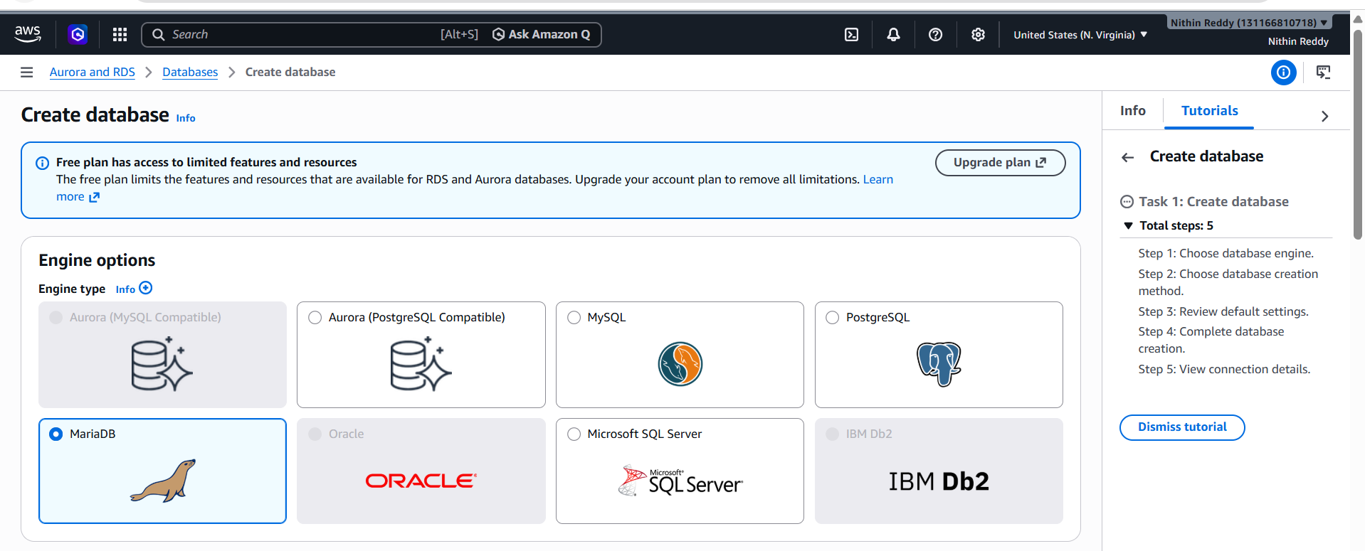

Step 4: Templates
Choose:
Free Tier
⚠️ If Free Tier is not shown:
Choose:
Dev/Test
with:
db.t3.micro
or smallest available.
📸 Screenshot

Step 5: Settings
DB Instance Identifier
mariadb-rds
Master Username
admin
Master Password
Example:
Password@123
Confirm password.
⚠️ Save this password.
📸 Screenshot (hide password if required)

Step 6: Instance Configuration
Choose:
db.t3.micro
or smallest free-tier eligible option available.
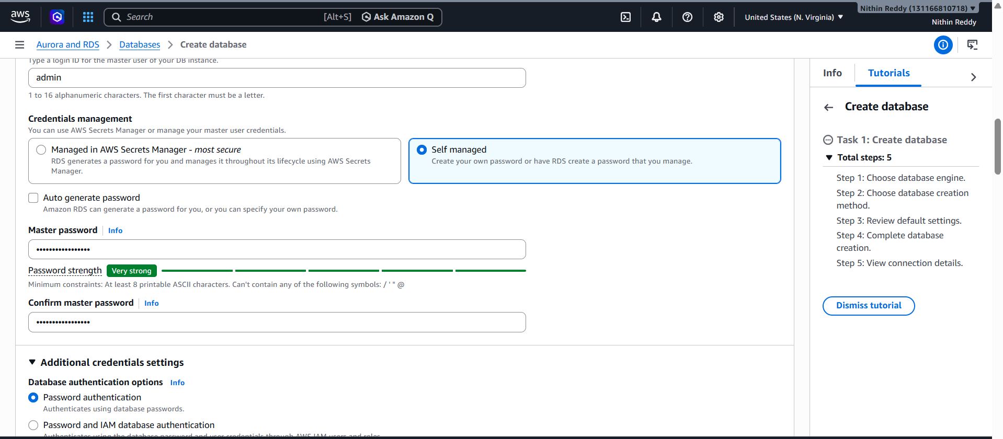
Step 7: Storage
Choose:
20 GB
Storage Type:
General Purpose SSD (gp3)
Leave defaults.
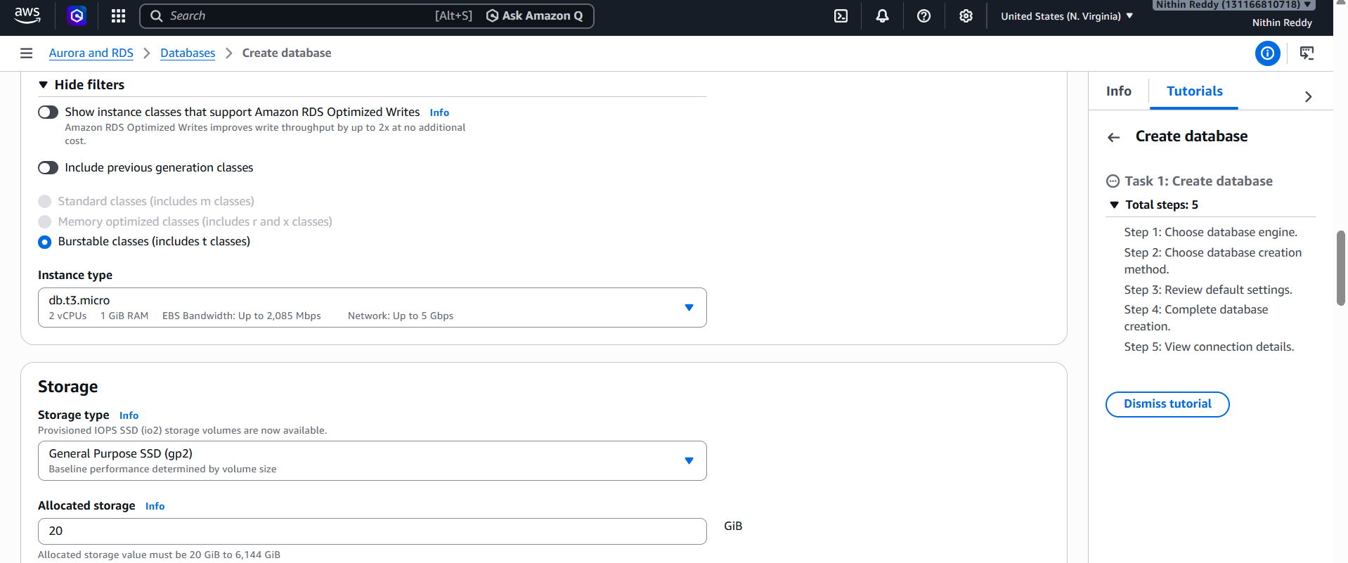
Step 8: Connectivity
Compute Resource
Choose:
Don't connect to an EC2 compute resource

VPC
Choose:
Default VPC
Same VPC as EC2.

Public Access
Choose:
Yes
This makes testing easier.

VPC Security Group
Choose:
Create New
Security Group Name:
mariadb-rds-sg

Availability Zone
Choose:
No Preference

Database Port
Keep:
3306

Step 9: Additional Configuration
Initial Database Name:
leave blank
We'll create it during migration.

Backup:
Keep default.
Monitoring:
Keep default.
Maintenance:
Keep default.
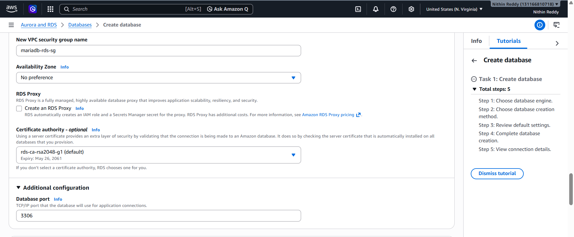
Step 10: Create Database
Click:
Create Database
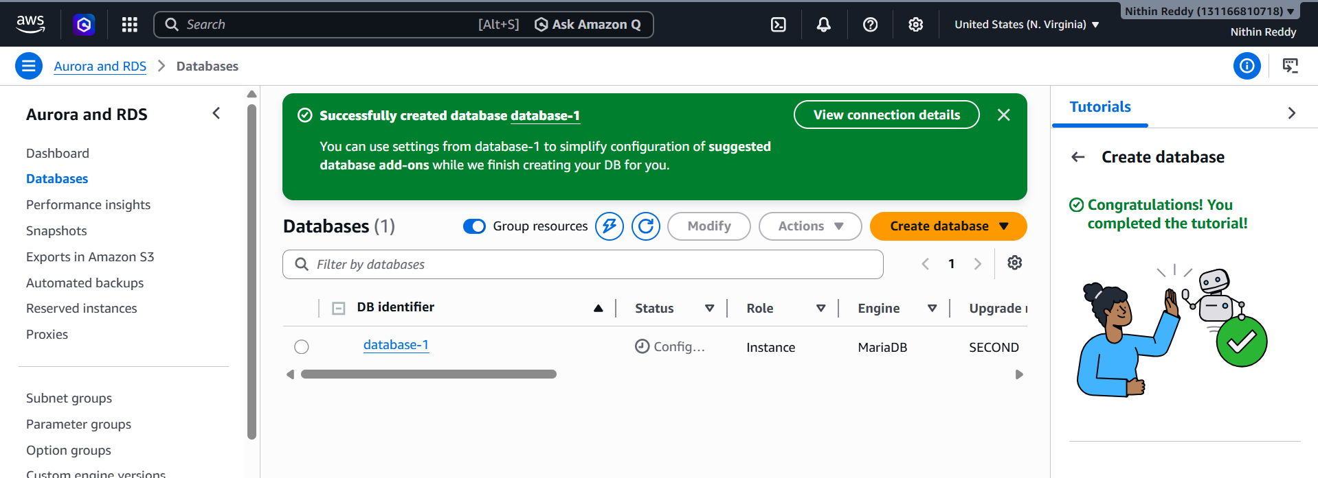
Step 11: Wait
Status:
Creating
Wait 5–15 minutes.
Eventually:
Available
📸 Screenshot when Available.
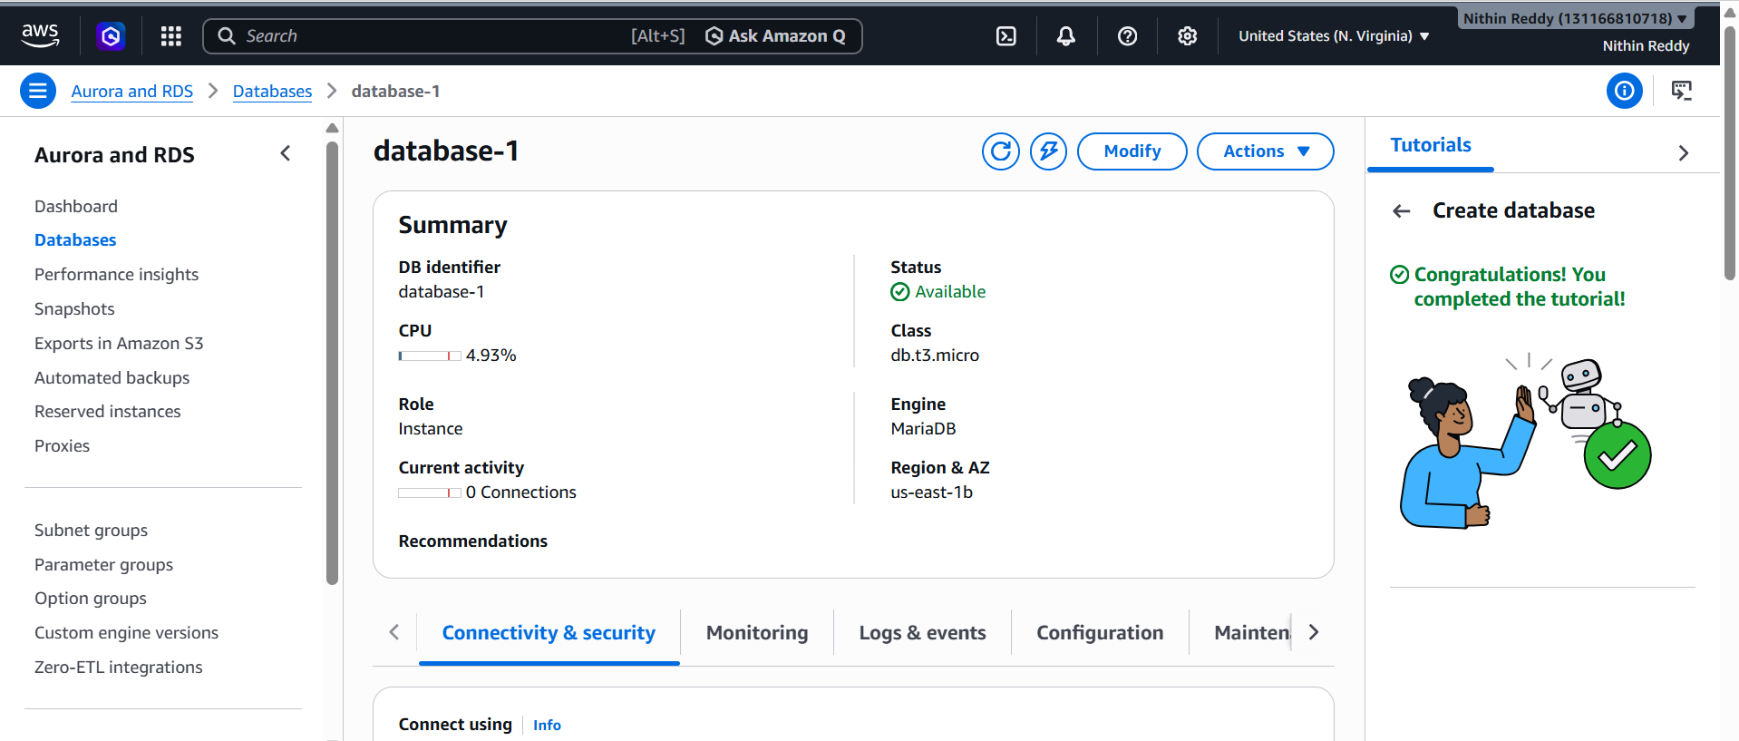
Step 12: Copy Endpoint
Open the RDS instance.
Find:
Connectivity & Security
Copy:
Endpoint
Example:
mariadb-rds.xxxxx.us-east-1.rds.amazonaws.com
Save it somewhere.
You will need it in Task 5.
📸 Screenshot showing Endpoint and Status Available.

Validation
Your RDS should show:
Status: Available
Engine: MariaDB
Endpoint: Present
Port: 3306

Common Errors
Error: Free Tier Not Available
Use:
Dev/Test
and choose the smallest instance.

Error: Creation Failed
Usually caused by:
Subnet Group issue
Use Default VPC and default subnet group.

Migrate Database from EC2 to RDS
Objective
Move the database you created on EC2 (companydb) into the MariaDB RDS instance.

Architecture
Current:
EC2
└── MariaDB
└── companydb
└── employees
Backup file:
companydb_backup.sql
Target:
RDS MariaDB
└── companydb
└── employees

Step 1: Copy RDS Endpoint
AWS Console
RDS
→ Databases
→ database-1
→ Connectivity & Security
Copy:
Endpoint
Example:
database-1.xxxxx.us-east-1.rds.amazonaws.com
Keep it somewhere.
database-1.c2v06sm20hv8.us-east-1.rds.amazonaws.com
Step 2: Configure Security Group
Open RDS Security Group.
RDS
→ database-1
→ Connectivity & Security
→ VPC Security Group
Click Security Group.
Add Inbound Rule:
Type | Port | Source
MySQL/Aurora | 3306 | EC2 Security Group
For quick testing:
Type: MySQL/Aurora
Port: 3306
Source: 0.0.0.0/0
(After assignment you can remove it.)
Save.
📸 Screenshot
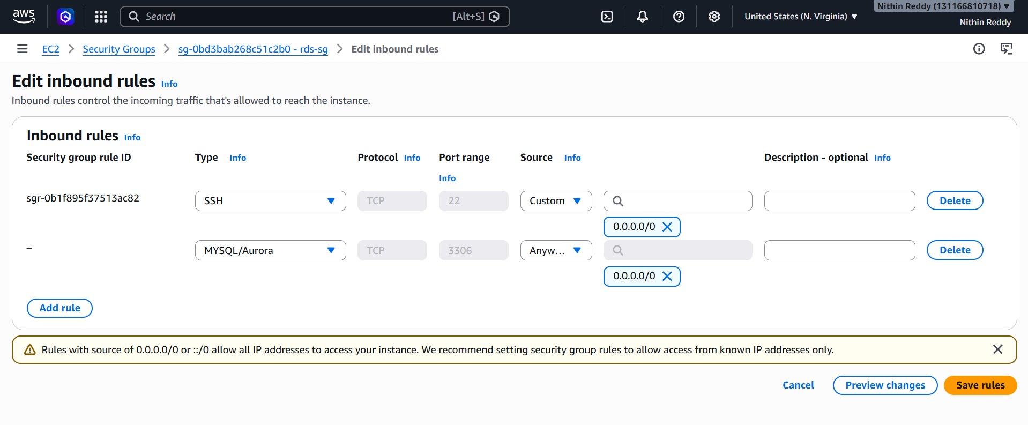
Step 3: Verify Backup Exists on EC2
SSH to EC2.
Run:
ls -lh companydb_backup.sql
Expected:
companydb_backup.sql
📸 Screenshot
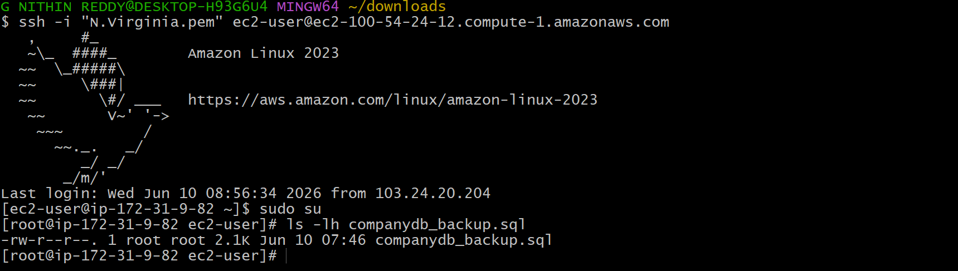
Step 4: Test Connection to RDS
Replace endpoint.
mysql -h YOUR-RDS-ENDPOINT -u admin -p
Example:
mysql -h database-1.xxxxx.us-east-1.rds.amazonaws.com -u admin -p
Enter password you created in Task 4.
Example:
Password@123
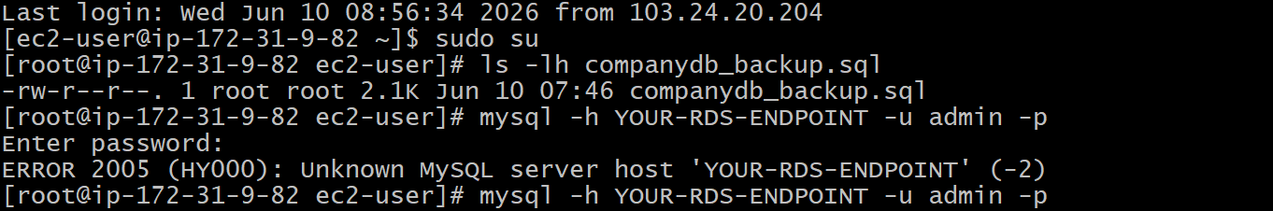
Expected Output
Welcome to the MariaDB monitor
Prompt:
MariaDB [(none)]>

Common Error 1
ERROR 2003:
Can't connect to MySQL server
Fix:
Check:
Security Group Port 3306
Public Access = Yes

Common Error 2
Access denied
Fix:
Use correct username/password.

Step 5: Create Database in RDS
Inside RDS MariaDB:
CREATE DATABASE companydb;
Verify:
SHOW DATABASES;
Expected:
companydb
📸 Screenshot

Step 6: Exit
exit;

Step 7: Import Backup into RDS
Back on Linux shell:
mysql -h YOUR-RDS-ENDPOINT -u admin -p companydb < companydb_backup.sql
Example:
mysql -h database-1.xxxxx.us-east-1.rds.amazonaws.com -u admin -p companydb < companydb_backup.sql
Enter password.
No output = Success.

Step 8: Verify Import
Connect again:
mysql -h YOUR-RDS-ENDPOINT -u admin -p

Run:
USE companydb;

Check tables:
SHOW TABLES;
Expected:
employees
📸 Screenshot
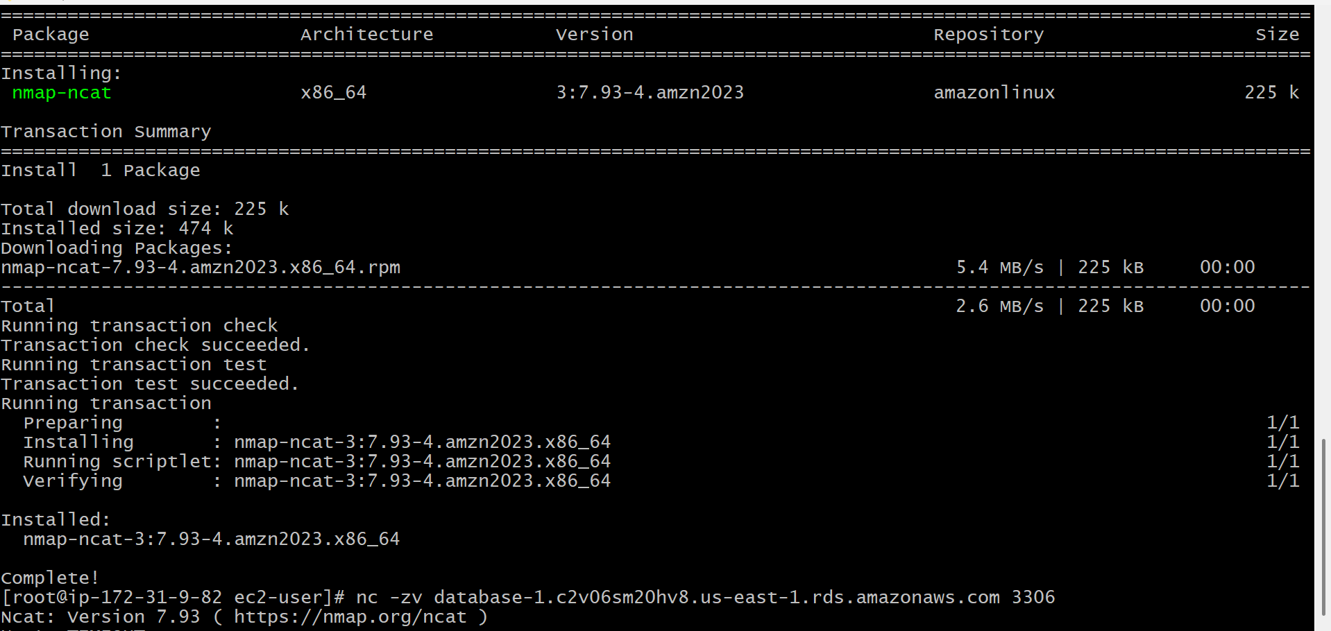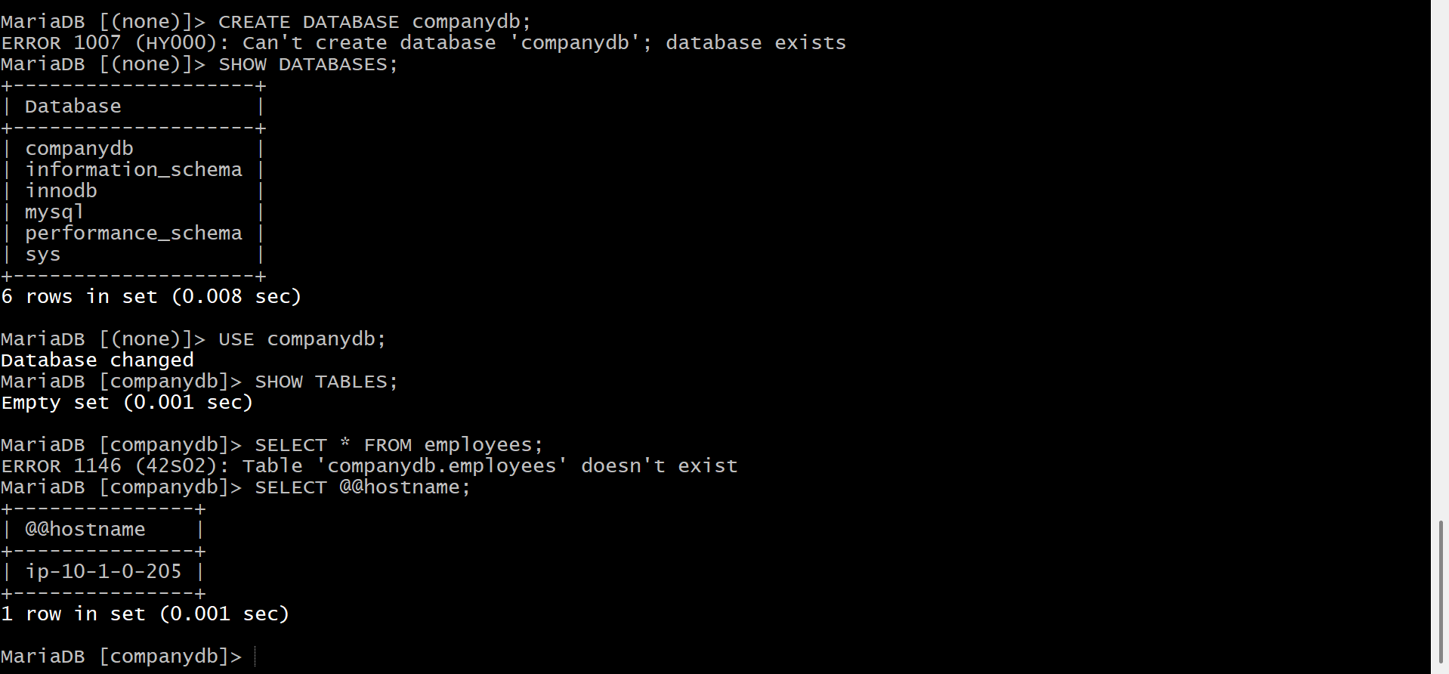
Step 9: Verify Data
Run:
SELECT * FROM employees;
Expected:
+----+--------+------------+
| id | name | department |
+----+--------+------------+
| 1 | Nithin | DevOps |
| 2 | John | AWS |
| 3 | David | Cloud |
+----+--------+------------+
📸 IMPORTANT Screenshot
This is the proof that migration worked.
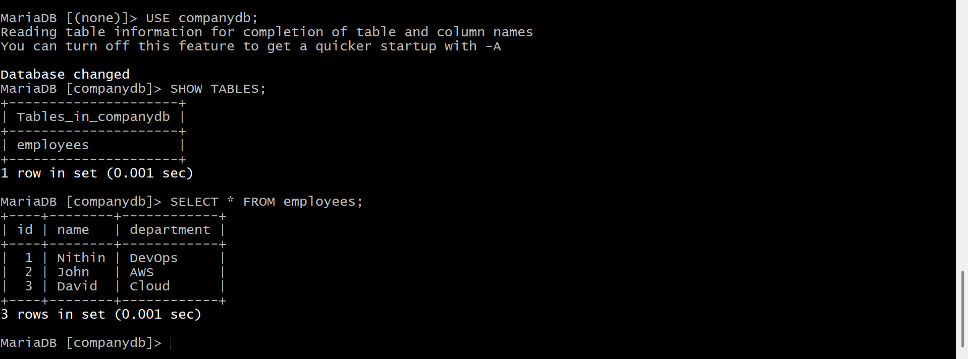
Validation Commands
Run:
SHOW TABLES;
and
SELECT * FROM employees;
Both should work from RDS.

Submission Evidence
Screenshot 1
ls -lh companydb_backup.sql
Screenshot 2
CREATE DATABASE companydb;
Install MySQL on EC2
Objective
Install MySQL client/software on the EC2 instance.
Outcome
EC2 should be able to run MySQL commands and connect to a MySQL database.
Dependency
None
Can be done without Tasks 4 and 5.

Step 1: Check Current MariaDB
You already have MariaDB installed.
Verify:
mysql --version
You should see something like:
MariaDB 10.5.x
📸 Screenshot

Step 2: Install MySQL Client
On Amazon Linux 2023:
sudo dnf install mysql -y
Wait for installation to complete.

Step 3: Verify Installation
Run:
mysql --version
Expected:
mysql Ver 8.x
or MariaDB client version depending on package.
📸 Screenshot (Required for Task 6)

Step 4: Check Package Installed
Run:
rpm -qa | grep mysql
or
dnf list installed | grep mysql
Expected:
mysql
mysql-common
📸 Screenshot

Step 5: Check MySQL Command Availability
Run:
which mysql
Expected:
/usr/bin/mysql
📸 Screenshot
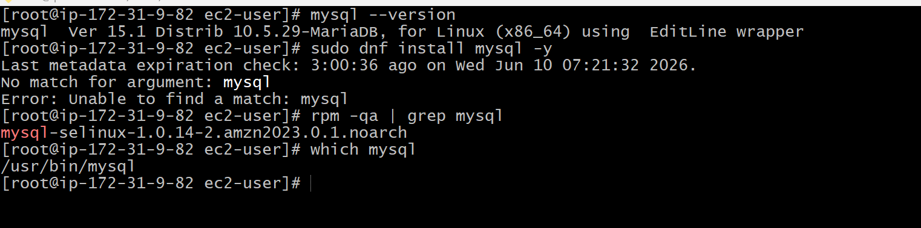
Validation
Run all three:
mysql --version
Errors occurred :
No match for argument: mysql
Run:
sudo dnf update -y
sudo dnf install mysql -y

Task 8: Configure Multi-AZ for RDS
Objective
Configure the MariaDB RDS instance to use Multi-AZ deployment for high availability.
Outcome
AWS creates a standby database in another Availability Zone and automatically replicates data.
What is Multi-AZ?
Without Multi-AZ:
AZ-1
└── Primary RDS
With Multi-AZ:
AZ-1 AZ-2
└── Primary RDS <==> Standby RDS
Benefits:
✅ High Availability
✅ Automatic Failover
✅ Data Replication

Step 1: Open RDS
AWS Console →
RDS
→ Databases
→ database-1
Verify Status:
Available

Step 2: Modify Database
Click:
Modify

Step 3: Enable Multi-AZ
Scroll to:
Availability & durability
Find:
Multi-AZ deployment
Change:
Single-AZ
to
Multi-AZ DB Instance
📸 Screenshot

Step 4: Apply Changes
Scroll down.
Choose:
Apply immediately
Click:
Modify DB Instance

Step 5: Wait
Status changes:
Modifying
Then:
Available
This can take several minutes.
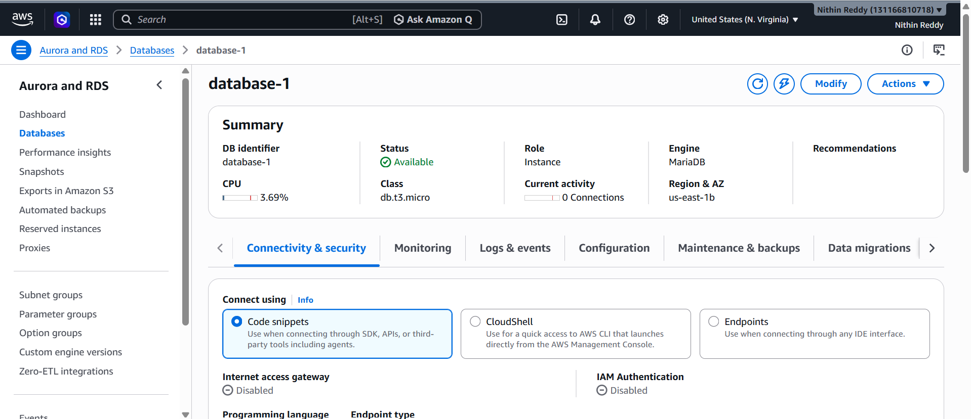
Step 6: Verify Multi-AZ
Open:
RDS
→ database-1
Check:
Multi-AZ
Expected:
Yes
or
Enabled
📸 IMPORTANT Screenshot
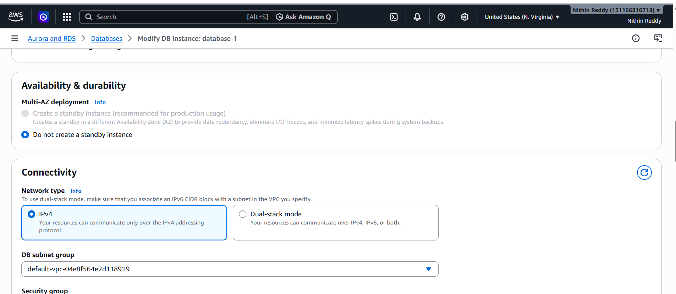
Validation
Open:
RDS
→ database-1
→ Configuration
Verify:
Multi-AZ: Yes

Submission Evidence
Screenshot 1
Before:
Multi-AZ = No
Screenshot 2
Modify screen showing:
Multi-AZ DB Instance selected

Take Backup of DB and Restore the DB
Since you already have MariaDB RDS (database-1), use it for this task.

Objective
- Create a backup (snapshot) of the RDS database.
- Restore a new database from that backup.

Outcome
database-1 (Original RDS)
↓
Snapshot Created
↓
Restore Snapshot
↓
database-restore (New RDS)

Prerequisites
✅ Task 4 completed (MariaDB RDS exists)
✅ Task 5 completed (data migrated)

Step 1: Verify Data Before Backup
Connect to RDS:
mysql --ssl -h database-1.c2v06sm20hv8.us-east-1.rds.amazonaws.com -u admin -p
Run:
USE companydb;
SELECT * FROM employees;
📸 Screenshot
Expected:
1 Nithin DevOps
2 John AWS
3 David Cloud
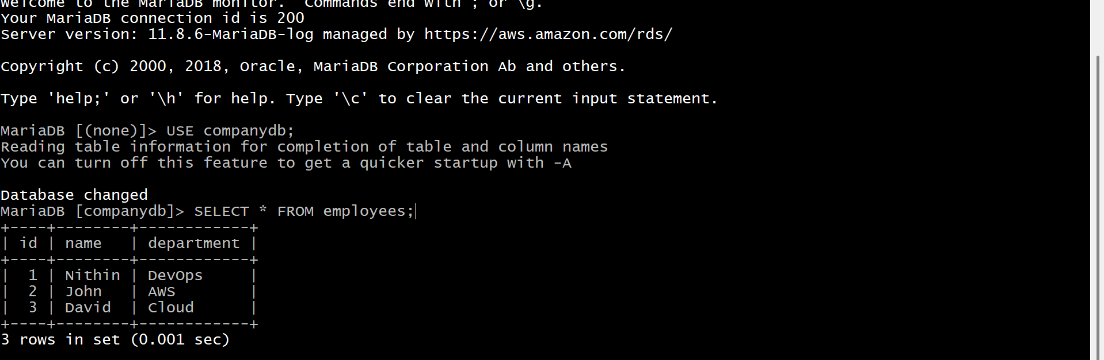
Step 2: Create Manual Snapshot
AWS Console:
RDS
→ Databases
→ database-1
→ Actions
→ Take Snapshot
Snapshot Name:
database-1-snapshot
Click:
Take Snapshot
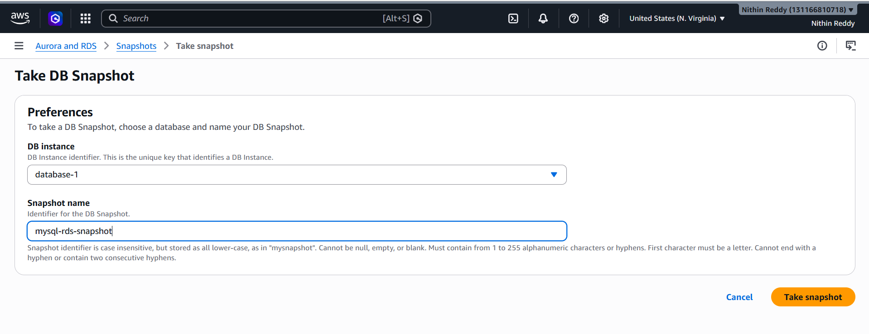
Step 3: Verify Snapshot
Go to:
RDS
→ Snapshots
Wait until:
Available
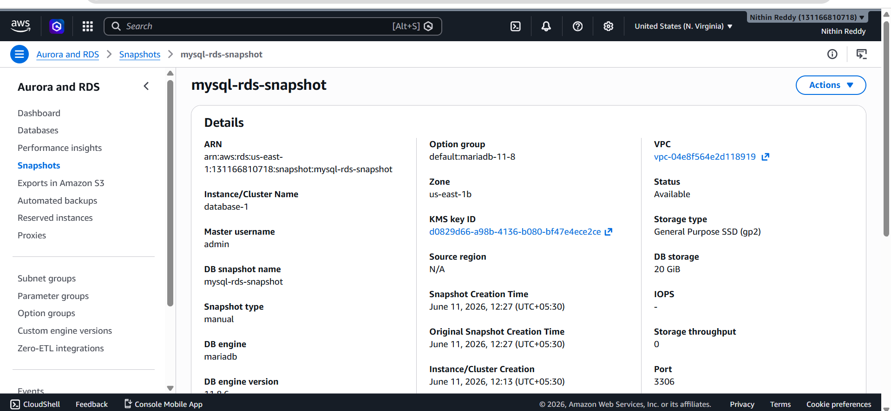

Step 4: Restore Snapshot
Select:
database-1-snapshot
Click:
Actions
→ Restore Snapshot
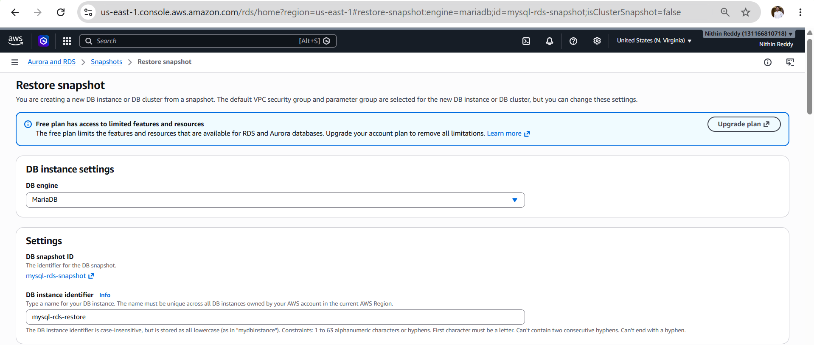
Step 5: Configure Restored Database
DB Identifier:
database-restore
Instance Class:
db.t3.micro
Public Access:
Yes
Security Group:
Use same SG as original DB.
Click:
Restore DB Instance

Step 6: Wait
Status:
Creating
Eventually:
Available
📸 Screenshot
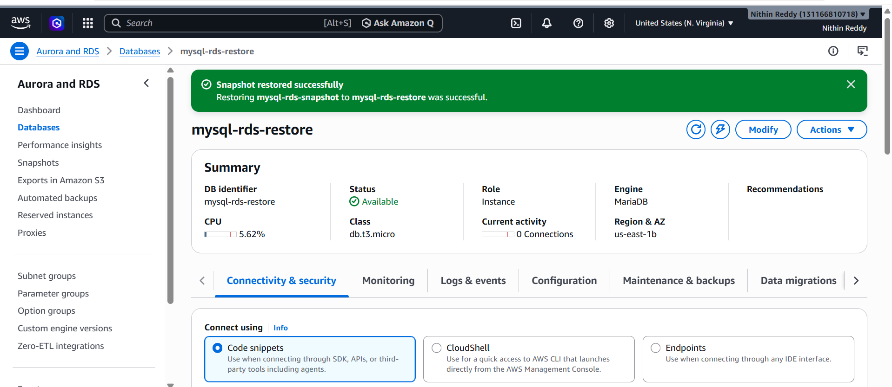
Step 7: Get Restored Endpoint
Open:
database-restore
→ Connectivity & Security
Copy Endpoint.
Example:
mysql-rds-restore.c2v06sm20hv8.us-east-
1.rds.amazonaws.comStep 8: Connect to Restored DB
mysql --ssl -h RESTORED-ENDPOINT -u admin -p
Run:
USE companydb;
SHOW TABLES;
SELECT * FROM employees;
Expected:
employees
and
1 Nithin DevOps
2 John AWS
3 David Cloud
📸 This is the main Task 9 proof.
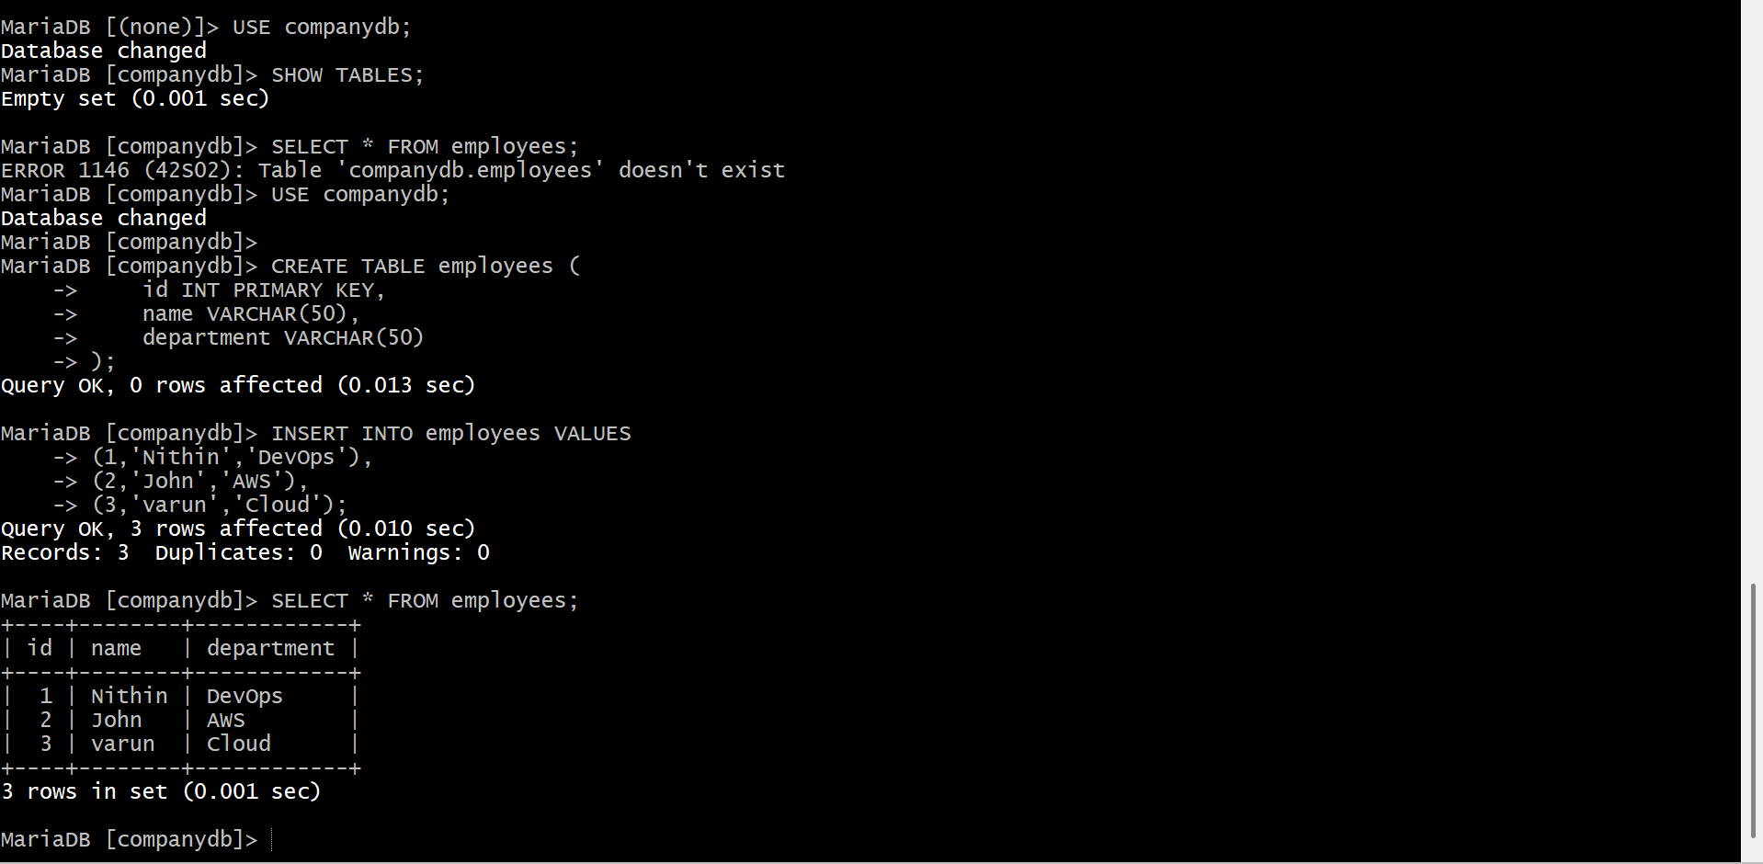

Validation
Run:
SHOW DATABASES;
USE companydb;
SHOW TABLES;
SELECT * FROM employees;
All should work.

Submission Evidence
Screenshot 1
Original DB data
SELECT * FROM employees;

Create Read Replica (Detailed)
Objective
Create a Read Replica for the primary RDS database to improve read scalability and demonstrate replication.

Outcome
Primary RDS (database-1)
│
▼
Read Replica (database-1-replica)
Data written to Primary will automatically replicate to Read Replica.

Prerequisites
✅ Task 4 completed (MariaDB RDS created)
✅ Task 5 completed (Data migrated)
✅ Primary RDS status = Available
Step 1: Verify Primary Database
AWS Console:
RDS
→ Databases
→ database-1
Verify:
Status = Available
📸 Screenshot
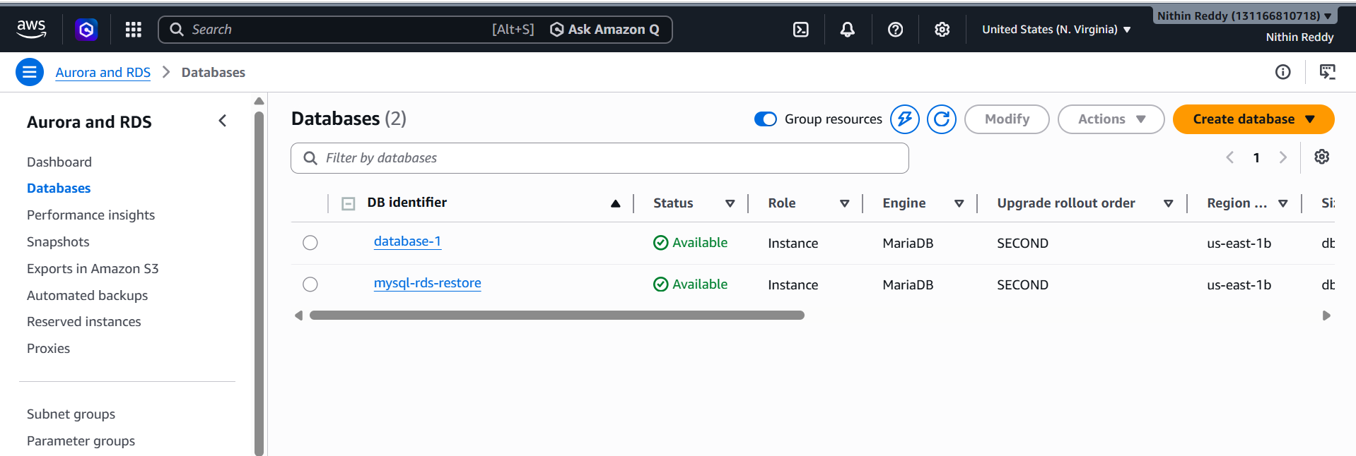
Step 2: Create Read Replica
Open:
RDS
→ Databases
→ database-1
Click:
Actions
→ Create Read Replica
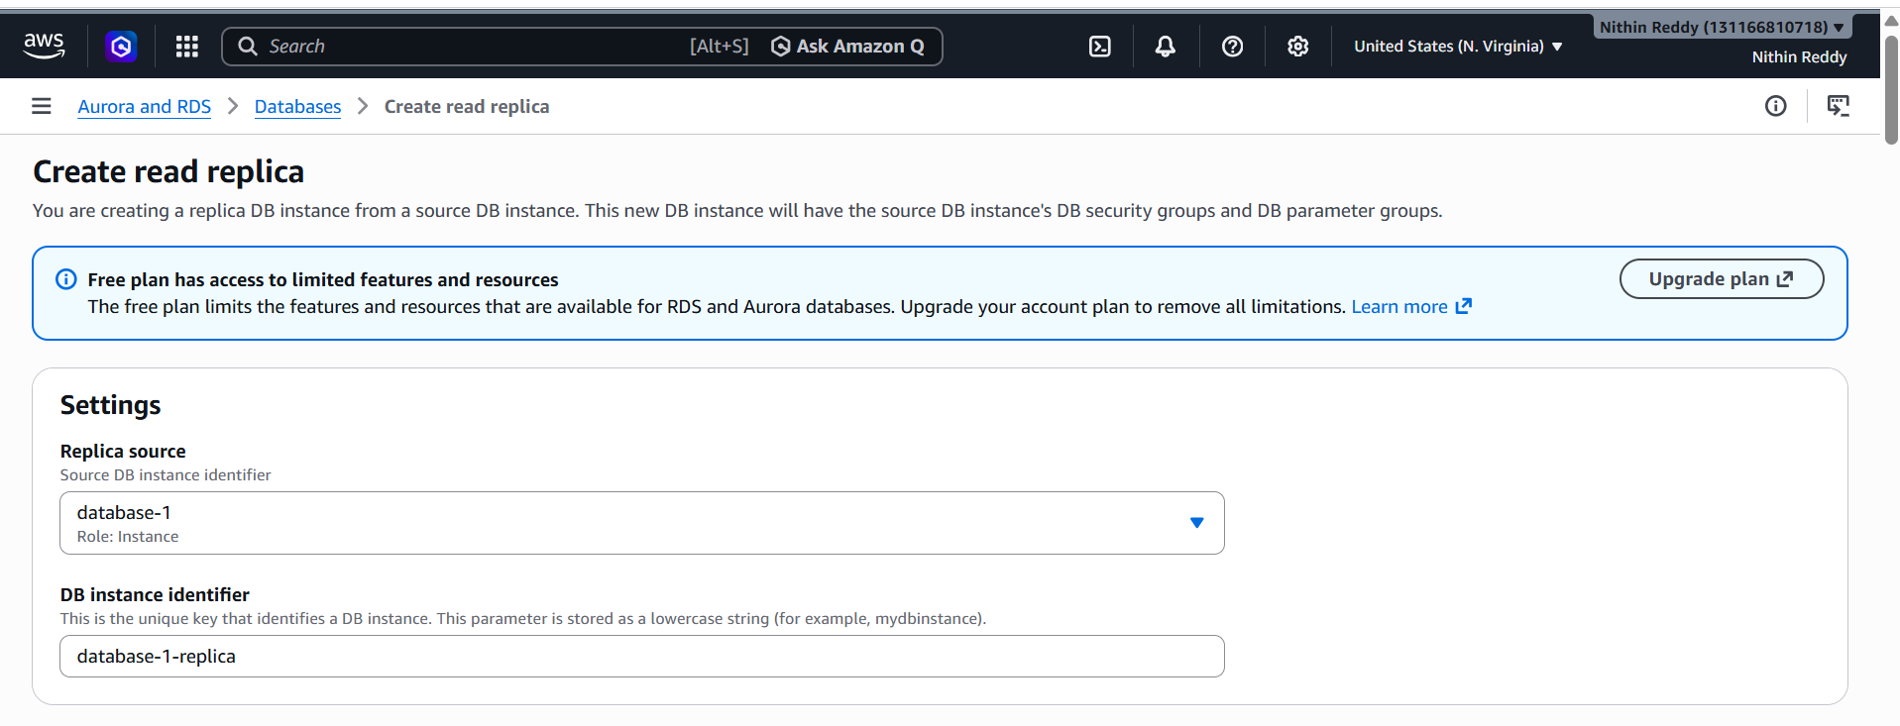
Step 3: Configure Replica
DB Instance Identifier
Example:
database-1-replica
Instance Class
Choose:
db.t3.micro
(or smallest available)
Availability Zone
No preference
Public Access
Yes
Security Group
Use same SG as primary database.
📸 Screenshot
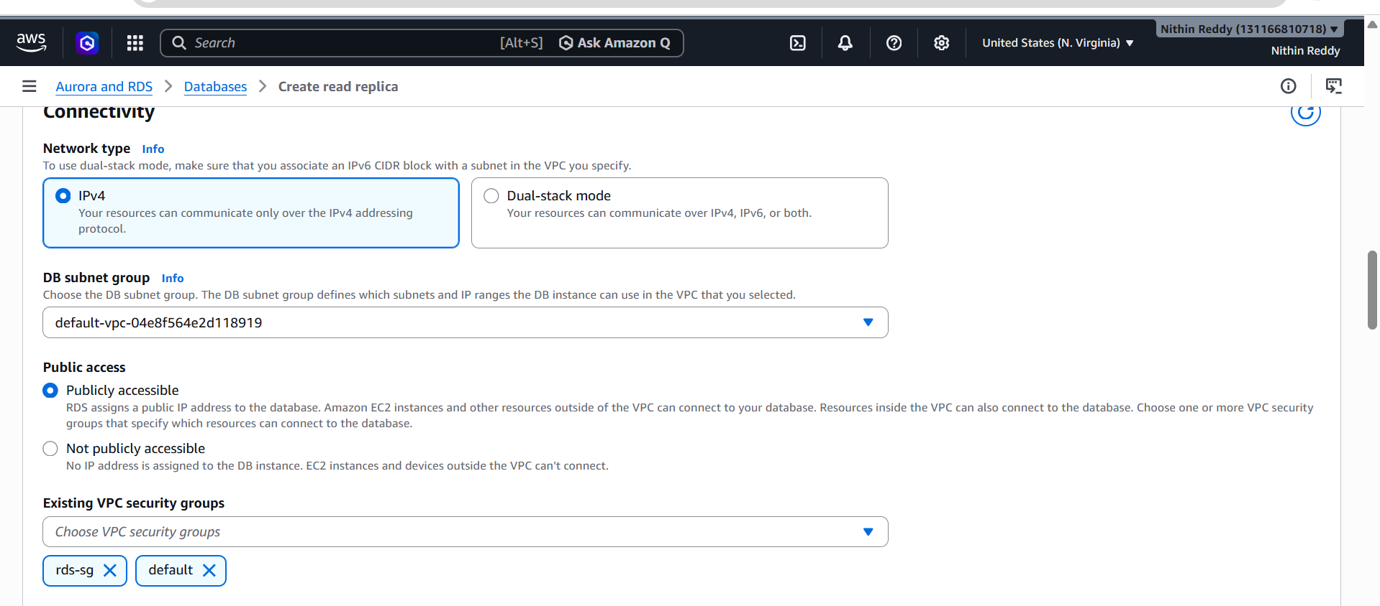

Step 4: Create Replica
Click:
Create Read Replica
Status:
Creating
Wait 5–15 minutes.
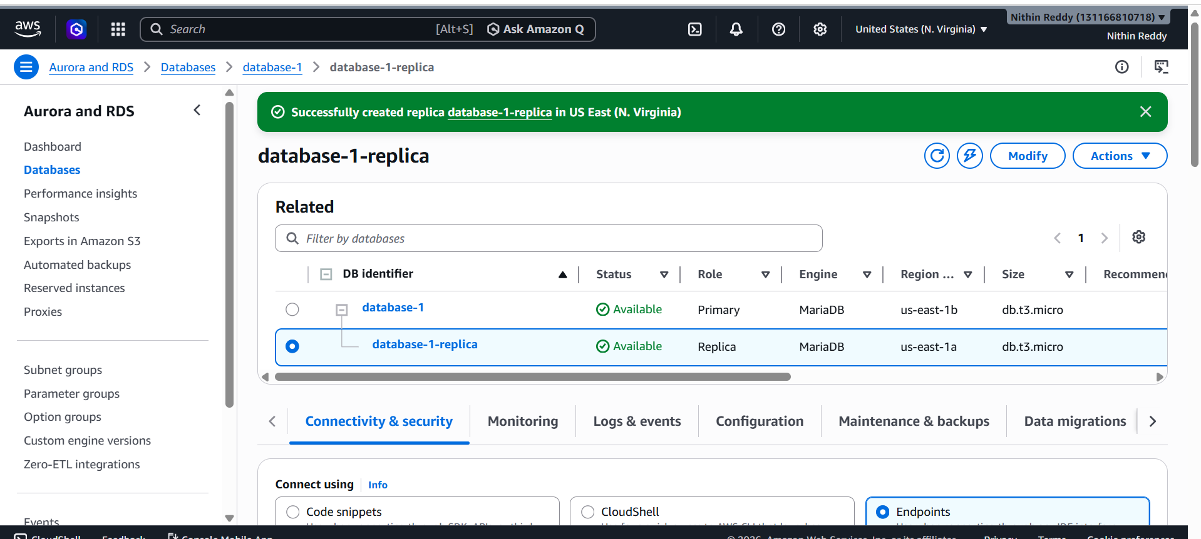
Step 5: Verify Replica
Go to:
RDS
→ Databases
Expected:
database-1 Available
database-1-replica Available
Replica should show:
Role = Read Replica
📸 Screenshot

Step 6: Get Replica Endpoint
Open:
database-1-replica
→ Connectivity & Security
Copy Endpoint.
Example:
database-1-replica.c2v06sm20hv8.us-east-1.rds.amazonaws.com
📸 Screenshot

Step 7: Connect to Read Replica
From EC2:
mysql --ssl -h database-1-replica.xxxxx.us-east-1.rds.amazonaws.com -u admin -p
Enter password.
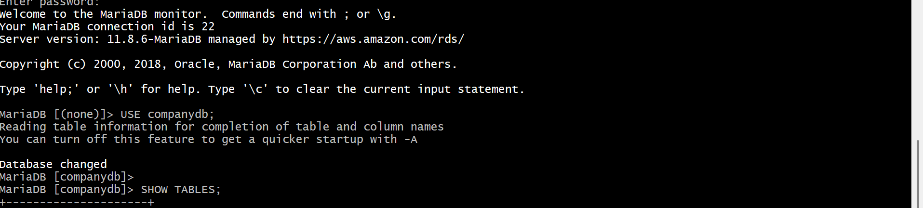
Step 8: Verify Replicated Data
Run:
SHOW DATABASES;
USE companydb;
SHOW TABLES;
SELECT * FROM employees;
Expected:
+----+--------+------------+
| id | name | department |
+----+--------+------------+
| 1 | Nithin | DevOps |
| 2 | John | AWS |
| 3 | David | Cloud |
+----+--------+------------+
📸 Screenshot (Main proof)

Step 9: Demonstrate Replication
Connect to Primary RDS:
mysql --ssl -h database-1.c2v06sm20hv8.us-east-1.rds.amazonaws.com -u admin -p
Insert new data:
USE companydb;
INSERT INTO employees VALUES
(4,'Alex','Support');
Verify:
SELECT * FROM employees;

Wait 30–60 seconds.
Connect to Replica:
mysql --ssl -h REPLICA-ENDPOINT -u admin -p
Run:
USE companydb;
SELECT * FROM employees;
Expected:
1 Nithin DevOps
2 John AWS
3 David Cloud
4 Alex Support
This proves replication works.
📸 Screenshot
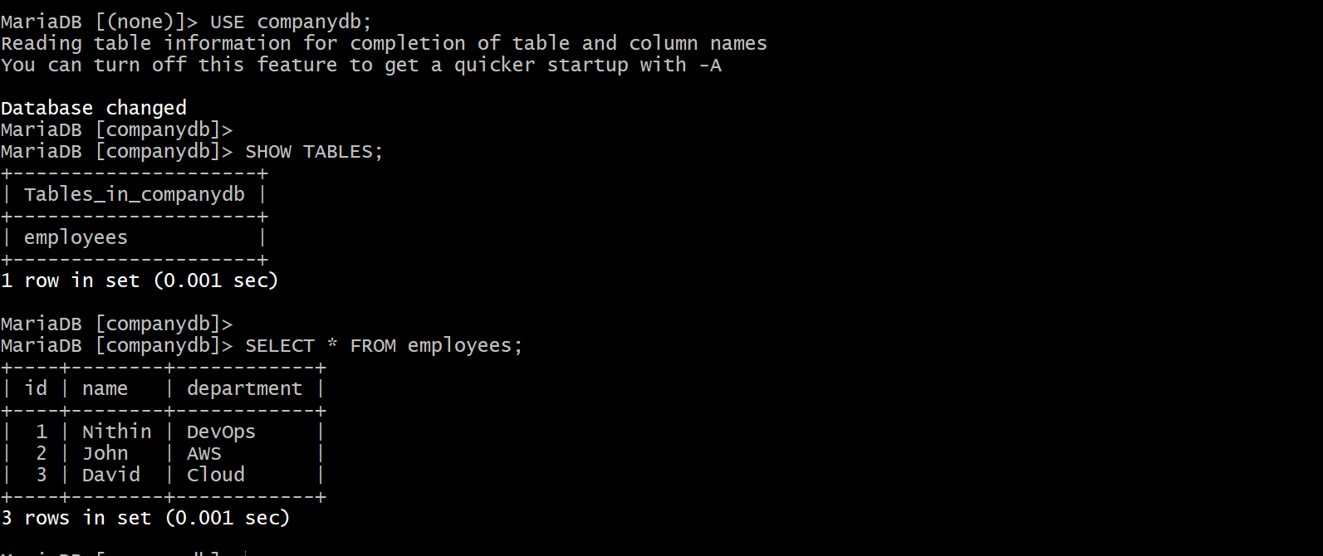
Validation
Run on Replica:
SHOW DATABASES;
USE companydb;
SELECT * FROM employees;
Common Errors
Error
Create Read Replica option disabled
Fix:
Verify:
Primary DB Status = Available

Error
Can't connect to replica

